Intune connector that allows Intune to work directly with System Center Configuration
Manager. Here are the steps required to sideload applications into Microsoft Intune:
1. Upload your application into Microsoft Intune. To do this, click the Add Apps link (shown in Figure 6.19).
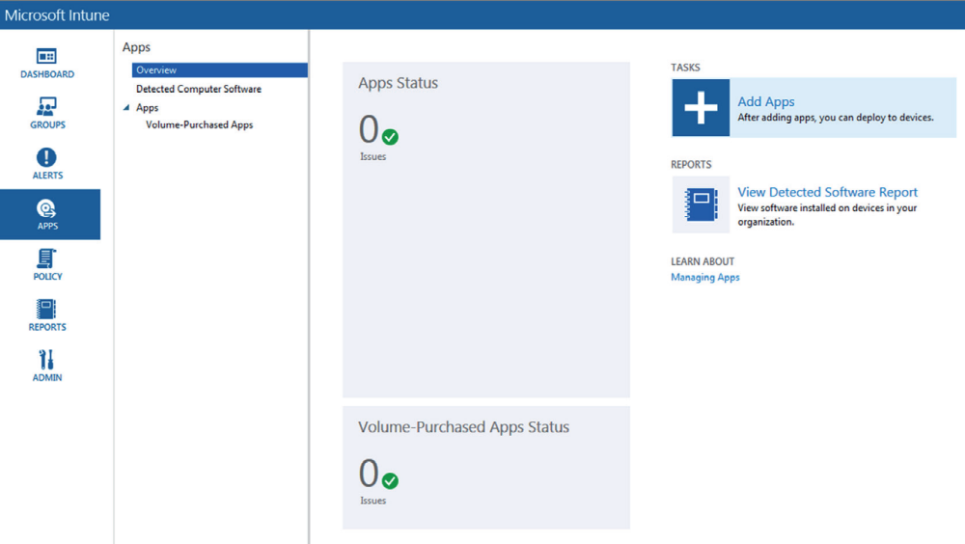

2. A dialog box will appear asking you if you want to download a setup.exe file. Click Yes. This is the Microsoft Intune Software Publisher. After it is downloaded, click the exe. The Software Publisher dialog box will appear, asking if you want to install. Click Run (shown in Figure 6.20).
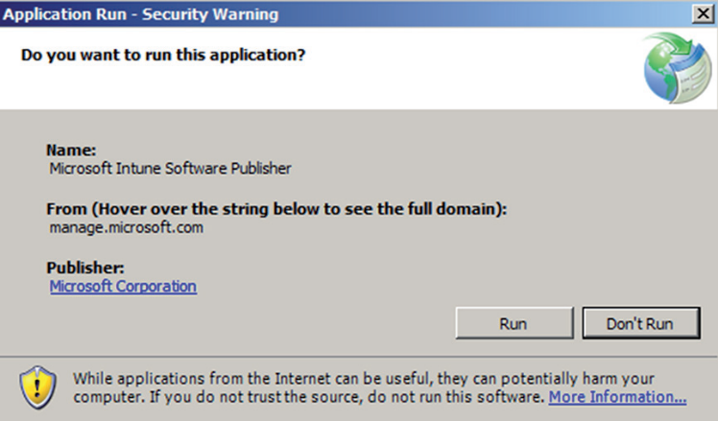

3. The Microsoft Intune Software Publisher sign-in screen will appear. Enter the credentials for a Microsoft account tied to Intune and click the Sign In link.
4. At the Software Setup page, choose the Windows application package software installer type and the Universal Naming Convention (UNC) path to the application.
5. When the Software Description page appears, choose the publisher, user-friendly name, and description of the app. Click Next. When the Add Software Wizard is complete, the app will be listed in the Managed Software node in the Software workspace.

Once an application is uploaded to Intune, the next step would be to deploy the application
to your users. To deploy the application to the users, you assign the application to the
created Windows Intune groups. While in the Windows Intune portal, you would click the
Apps link and then choose the app for deployment. The following steps describe how to
deploy the application:

1. Open the Microsoft Intune administrator console and click the Apps link.
2. Select the application that you want to deploy, and then click the Manage Deployment link.
3. Choose the user or device groups that you want to deploy the application to.
4. On the Deployment Action page, configure for approval (Required, Available, Not Applicable, or Uninstall) or deadline (when the application must be installed).
5. If the application that you are deploying has the ability to be configured by a mobile application management policy, then the Mobile App Management page will be displayed. On this page an administrator can choose the mobile application management policy that they want with this application.
6. If the application that you are deploying has the ability to be configured by a VPN profile, then the VPN Profile page will be displayed. Here is where you can choose the iOS apps with the VPN profile.

